**Sourcecode:**

**1.OperationsDAO:**

package com.project.lockedme;

import java.io.File;

import java.io.IOException;

import java.util.Arrays;

import java.util.Set;

import java.util.TreeSet;

import java.util.regex.Matcher;

import java.util.regex.Pattern;

public class OperationsDAO {

public void listAllFiles(String path) {

if (path == null || path.isEmpty() || path.isBlank())

throw new NullPointerException("Path cannot be Empty or null");

File dir = new File(path);

if(!dir.exists())

throw new IllegalArgumentException("Path does not exist");

if(dir.isFile())

throw new IllegalArgumentException("The given path is a file. A directory is expected.");

String [] files = dir.list();

System.out.println("\n***********************************");

if(files != null && files.length > 0) {

Set<String>filesList = new TreeSet<String>(Arrays.asList(files));

System.out.println("The Files in "+ dir.getAbsolutePath() + " are: \n");

for(String file1:filesList) {

System.out.println(file1);

}

System.out.println("\nTotal Number of files: "+ filesList.size());

}else {

System.out.println("Directory is Empty");

}

}

public void createNewFile(String path , String fileName) throws IOException {

if (path == null || path.isEmpty() || path.isBlank())

throw new NullPointerException("Path cannot be Empty or null");

if (fileName == null || fileName.isEmpty() || fileName.isBlank())

throw new NullPointerException("File Name cannot be Empty or null");

File newFile = new File(path + File.separator + fileName);

boolean createFile = newFile.createNewFile();

if (createFile) {

System.out.println("\nFile Successfully Created: " + newFile.getAbsolutePath());

}else if(!createFile) {

System.out.println("\nFile Already Exist.. Please try again." );

}

}

public void deleteFile(String path , String fileName) throws IOException {

if (path == null || path.isEmpty() || path.isBlank())

throw new NullPointerException("Path cannot be Empty or null");

if (fileName == null || fileName.isEmpty() || fileName.isBlank())

throw new NullPointerException("File Name cannot be Empty or null");

File newFile = new File(path + File.separator + fileName);

boolean deleteFile = newFile.delete();

if (deleteFile) {

System.out.println("\nFile deleted Successfully");

}else {

System.out.println("\nFile Not Found.. Please try again." );

}

}

public void searchFile(String path , String fileName){

if (path == null || path.isEmpty() || path.isBlank())

throw new NullPointerException("Path cannot be Empty or null");

if (fileName == null || fileName.isEmpty() || fileName.isBlank())

throw new NullPointerException("File Name cannot be Empty or null");

File dir = new File(path);

if(!dir.exists())

throw new IllegalArgumentException("Path does not exist");

if(dir.isFile())

throw new IllegalArgumentException("The given path is a file. A directory is expected.");

String [] fileList = dir.list();

boolean flag = false;

Pattern pat = Pattern.compile(fileName);

if(fileList != null && fileList.length > 0) {

for(String file:fileList) {

Matcher mat = pat.matcher(file);

if(mat.matches()) {

System.out.println("File Found at location: " + dir.getAbsolutePath());

flag = true;

break;

}

}

}

if(flag == false)

System.out.println("File Not Found.. Please try again.");

}

}

**2.Menus:**

package com.project.lockedme;

import java.io.IOException;

import java.util.Scanner;

public class Menus {

Scanner scan = new Scanner(System.in);

OperationsDAO dao = new OperationsDAO();

public void introScreen() {

System.out.println();

System.out.println("*********************************************************************");

System.out.println("* DEVELOPED BY NILADRI CHOWDHURY *");

System.out.println("*********************************************************************");

System.out.println("* LOCKEDME.COM *");

System.out.println("*********************************************************************");

System.out.println("* A Product of Lockers Pvt. Ltd *");

System.out.println("*********************************************************************");

System.out.println("\n\n");

}

public void exitScreen() {

System.out.println("* *");

System.out.println("* THANK YOU FOR VISITING LOCKEDME.COM *");

System.out.println("* *");

System.out.println("\n\n");

}

public void mainMenuOptions() {

System.out.println("| MAIN MENU |");

System.out.println("-----------------------------------------------------------------------");

System.out.println("| Enter your choice which you want to select: |");

System.out.println("| 1 - List All Files in ascending order |");

System.out.println("| 2 - Business-level operation menu |");

System.out.println("| 3 - Exit from the application |");

System.out.println("=======================================================================");

System.out.println("Enter your choice : ");

}

public void subMenuOptions() {

System.out.println("| FILE MENU |");

System.out.println("------------------------------------------------------------------------");

System.out.println("| Enter your choice for business: |");

System.out.println("| 1 - Add a file |");

System.out.println("| 2 - Delete a file from a directory |");

System.out.println("| 3 - Searching a file |");

System.out.println("| 4 - Exit from BLO |");

System.out.println("========================================================================");

System.out.println("Enter your choice : ");

}

public void mainMenu() {

int choice = 0;

char decision = 0;

do {

mainMenuOptions();

try {

choice = Integer.parseInt(scan.nextLine());

} catch (NumberFormatException e) {

System.out.println("\nInvalid Input \nValid Input Integers:(1-3)\n");

mainMenu();

}

switch (choice) {

case 1:

System.out.println();

try {

dao.listAllFiles(Main.path);

}catch(NullPointerException e) {

System.out.println(e.getMessage());

}catch(IllegalArgumentException e) {

System.out.println(e.getMessage());

}catch(Exception e) {

System.out.println(e.getMessage());

}

System.out.println("\n***********************************\n");

break;

case 2:

System.out.println();

subMenu();

break;

case 3:

System.out.println("\n Are you sure you want to exit ? ");

System.out.println(" (Y) ==> Yes (N) ==> No ");

decision = scan.nextLine().toUpperCase().charAt(0);

if(decision == 'Y') {

System.out.println("\n");

exitScreen();

System.exit(1);

}else if(decision == 'N') {

System.out.println("\n");

mainMenu();

}else {

System.out.println("\nInvalid Input \nValid Inputs :(Y/N)\n");

mainMenu();

}

default:

System.out.println("\nInvalid Input \nValid Input Integers:(1-3)\n");

mainMenu();

}

}while(true);

}

public void subMenu() {

String file = null;

String fileName = null;

int choice = 0;

do {

subMenuOptions();

try {

choice = Integer.parseInt(scan.nextLine());

} catch (NumberFormatException e) {

System.out.println("Invalid Input \nValid Input Integers:(1-4)");

subMenu();

}

switch (choice) {

case 1:

System.out.println("\n==> Adding a File...");

System.out.println("Please enter the file which you want to add : ");

file = scan.nextLine();

fileName = file.trim();

try {

dao.createNewFile(Main.path, fileName);

}catch(NullPointerException e) {

System.out.println(e.getMessage());

}catch(IOException e) {

System.out.println("Error occurred while adding file..");

System.out.println("Please try again...");

}catch(Exception e) {

System.out.println("Error occurred while adding file..");

System.out.println("Please try again...");

}

System.out.println("\n**********************************\n");

break;

case 2:

System.out.println("\n==> Deleting a File...");

System.out.println("Please enter the file which you want to delete : ");

file = scan.nextLine();

fileName = file.trim();

try {

dao.deleteFile(Main.path, fileName);

}catch(NullPointerException e) {

System.out.println(e.getMessage());

}catch(IOException e) {

System.out.println("Error occurred while Deleting File..");

System.out.println("Please try again...");

}catch(Exception e) {

System.out.println("Error occurred while Deleting File..");

System.out.println("Please try again...");

}

System.out.println("\n***********************************\n");

break;

case 3:

System.out.println("\n==> Searching a File...");

System.out.println("Please enter the file which you want to search : ");

file = scan.nextLine();

fileName = file.trim();

try {

dao.searchFile(Main.path, fileName);

}catch(NullPointerException e) {

System.out.println(e.getMessage());

}catch(IllegalArgumentException e) {

System.out.println(e.getMessage());

}catch(Exception e) {

System.out.println(e.getMessage());

}

System.out.println("\n***********************************\n");

break;

case 4: mainMenu();

break;

default:

System.out.println("Invalid Input \nValid Input Integers:(1-4)");

subMenu();

}

file = null;

fileName = null;

}while(true);

}

}

**3.Main:**

**package** com.project.lockedme;

**public** **class** Main {

/*Enter your desired Directory path */

**public** **static** **final** String ***path*** = "F:\\Lockedme\\Niladri";

**public** **static** **void** main(String[] args) {

Menus menu = **new** Menus();

menu.introScreen();

menu.mainMenu();

}

}

**Outputs:**

**Welcome Screen:**

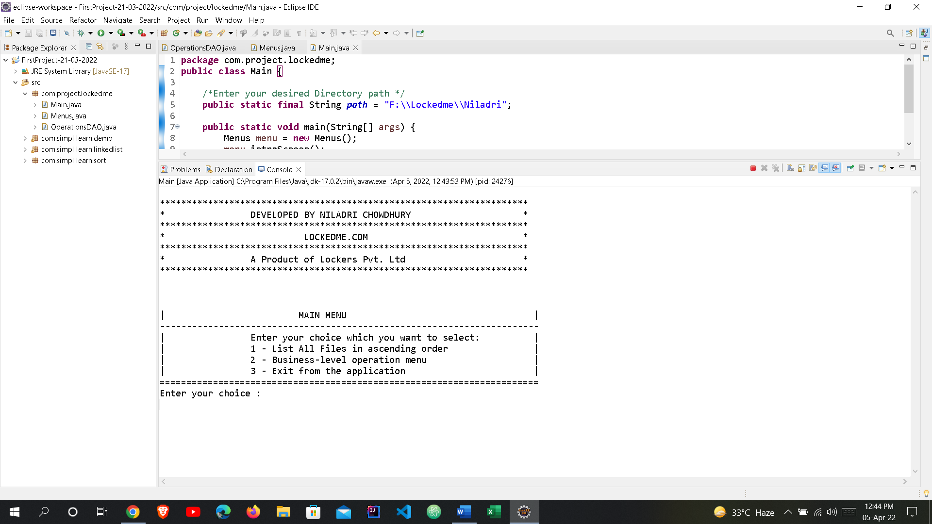

**Main Menu:**



**Choices:**

**1.Listing all the files in ascending order:**

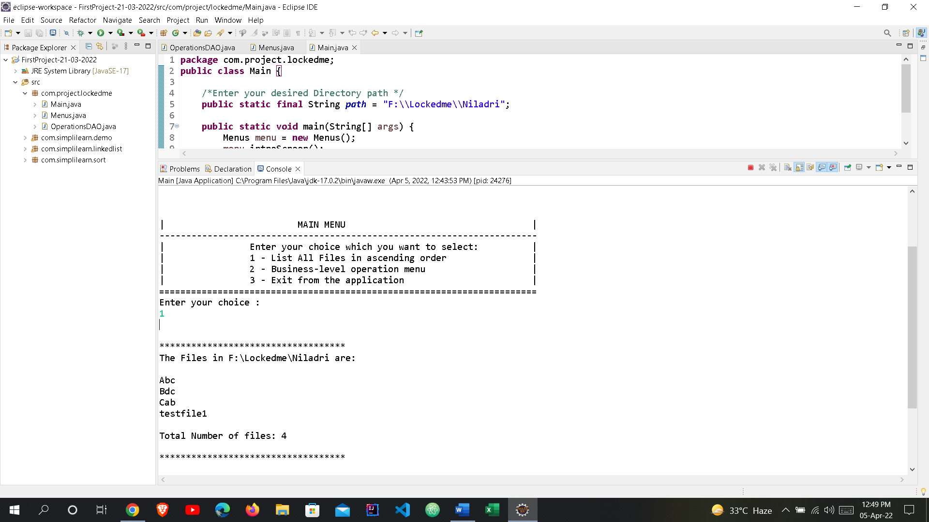

**2.Business-Level operation menu:**

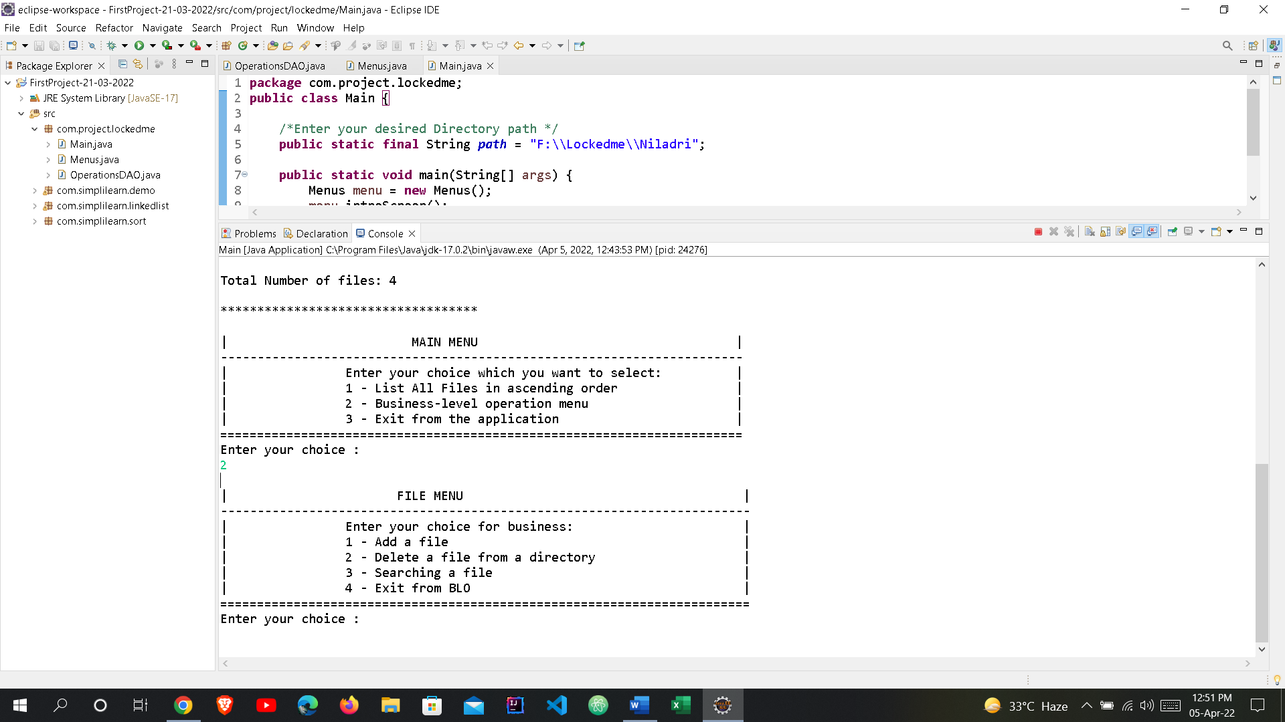

1. **Adding a File in the directory:**

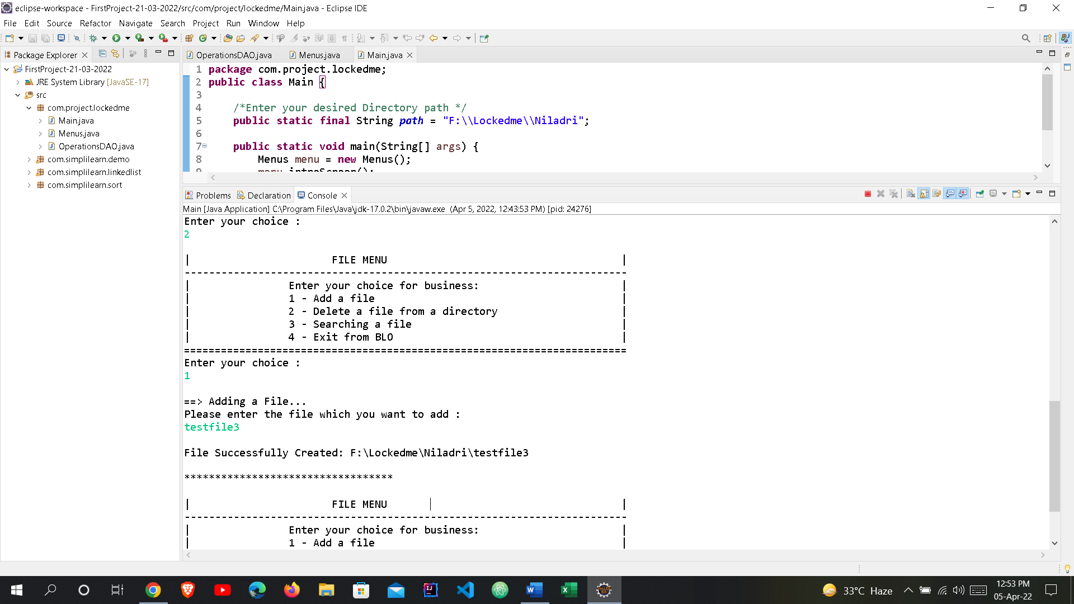

1. **Deleting a File from the directory:**

**i. If the file is present in the directory:**

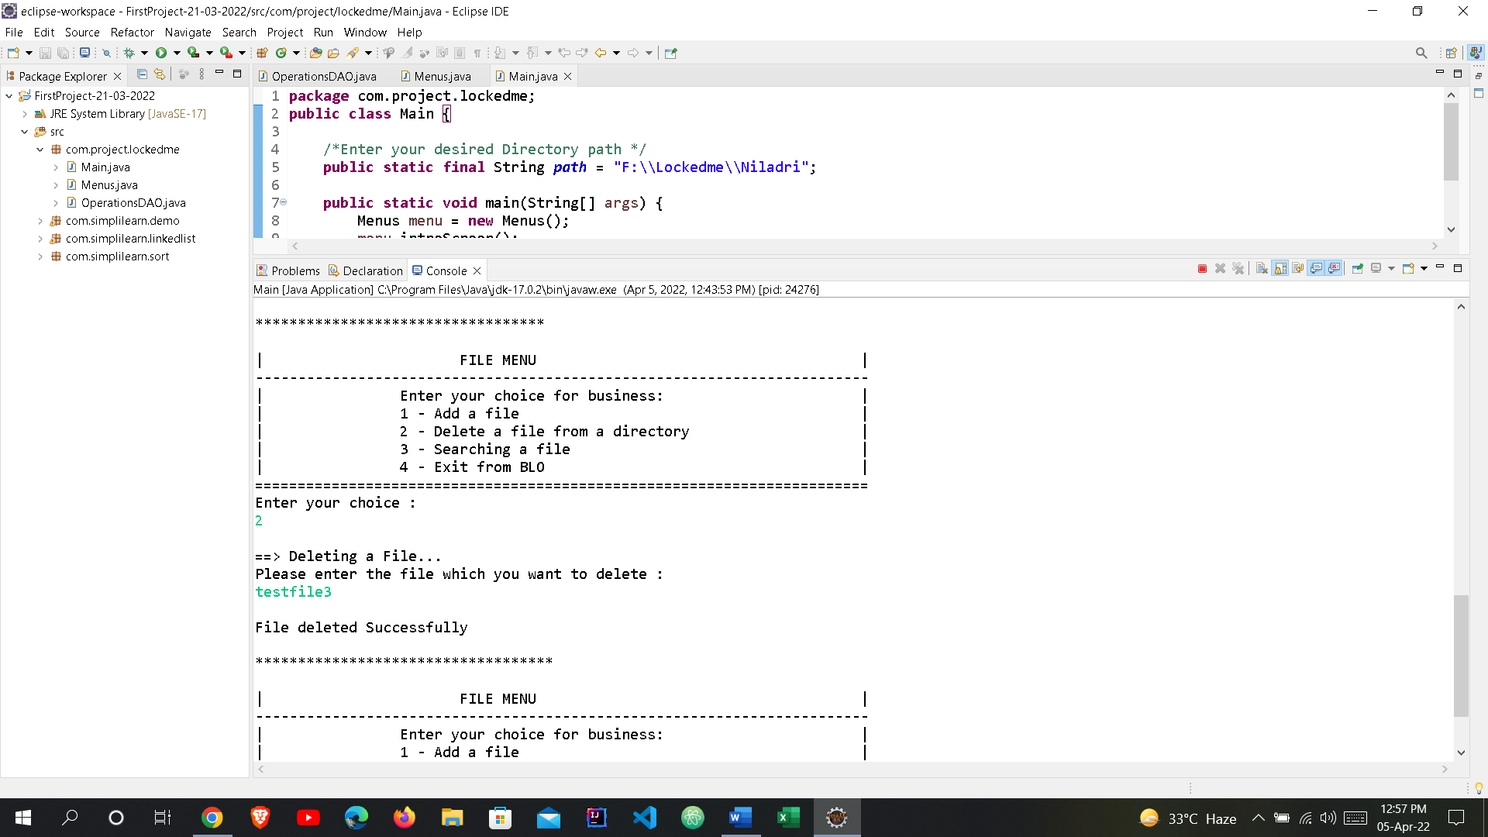

**ii. If the file is not present in the directory:**

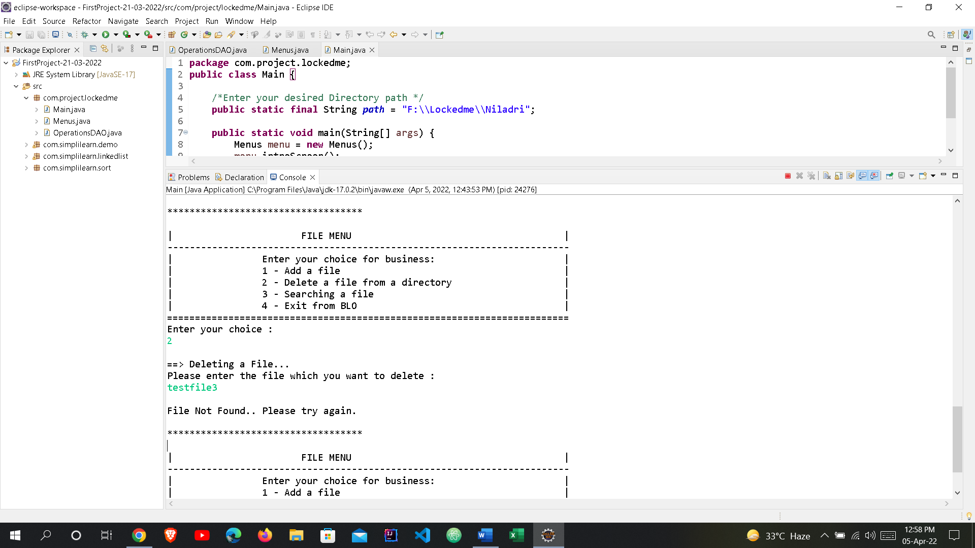

1. **Searching a File in a directory:**

**i. If the file searched is present in the directory:**

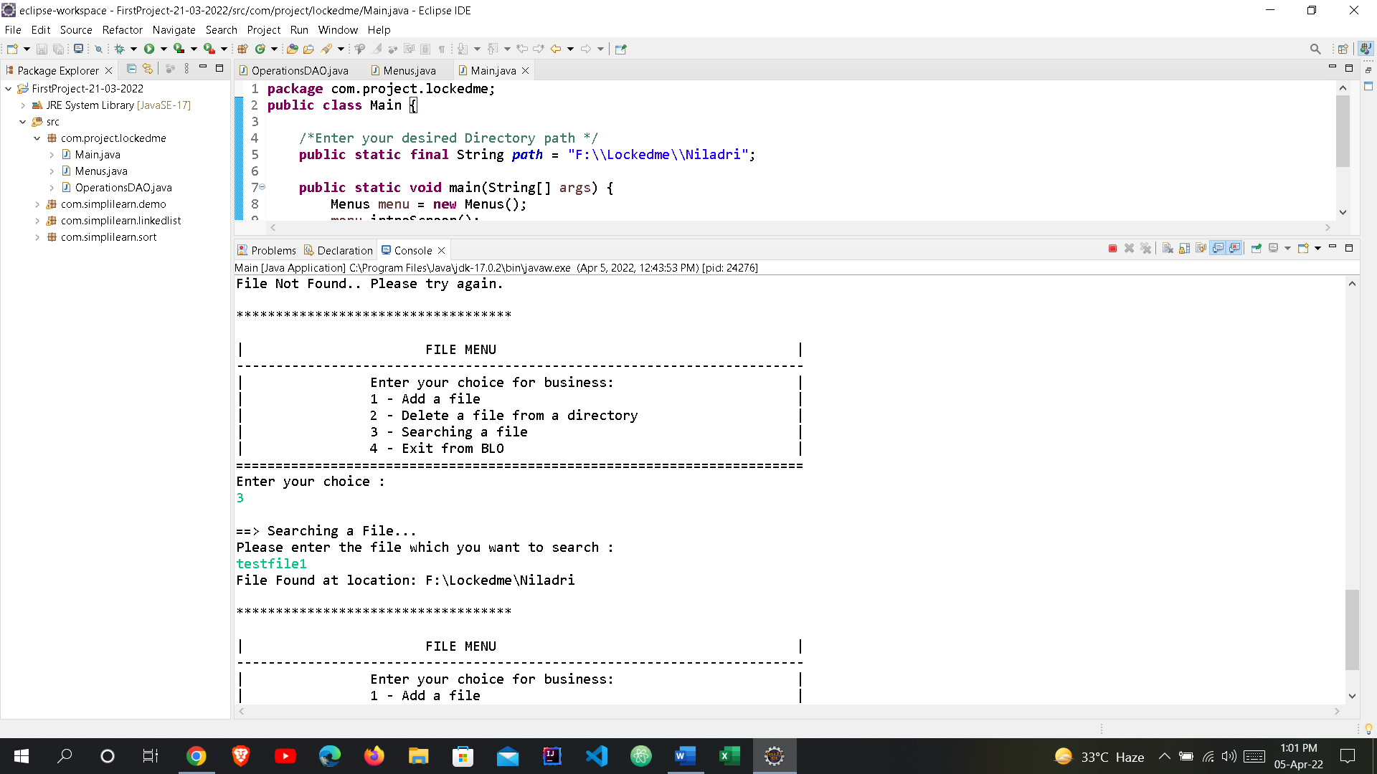

**ii. If the file searched is not present in the directory:**

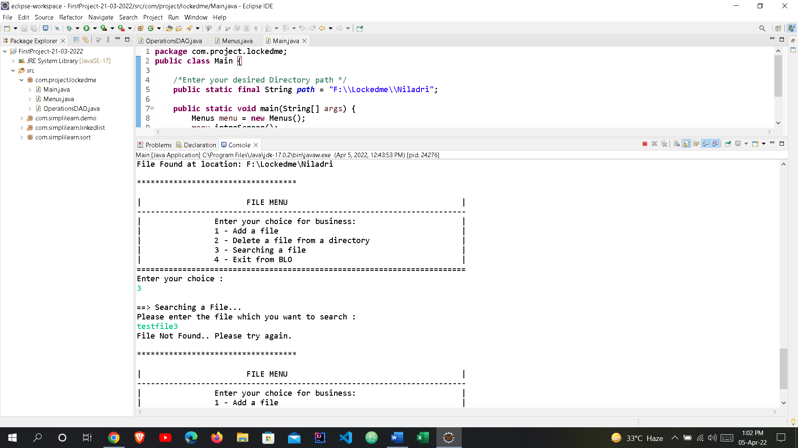

**d. Exiting from BLO:**

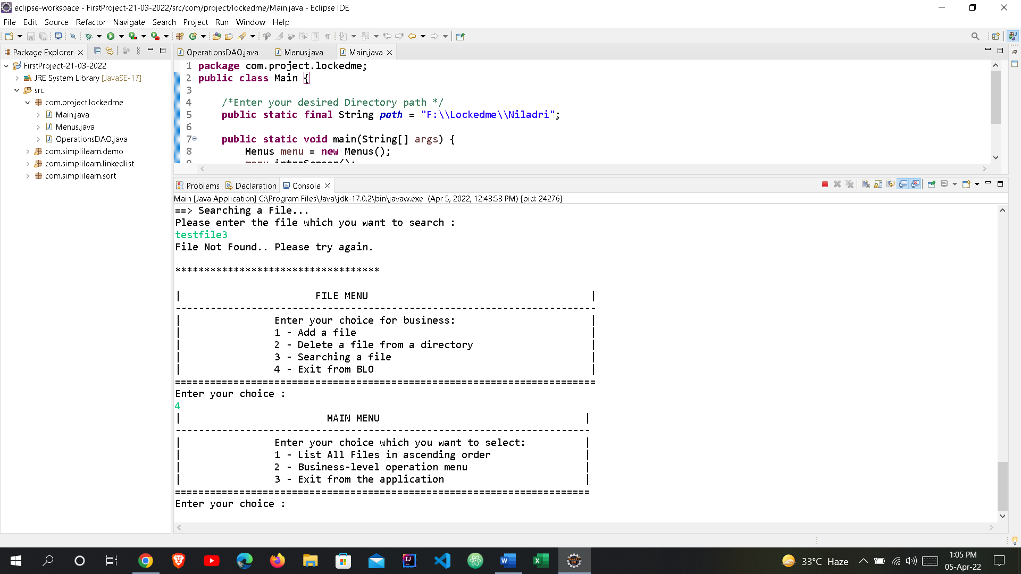

**3. Exit from the Application:**

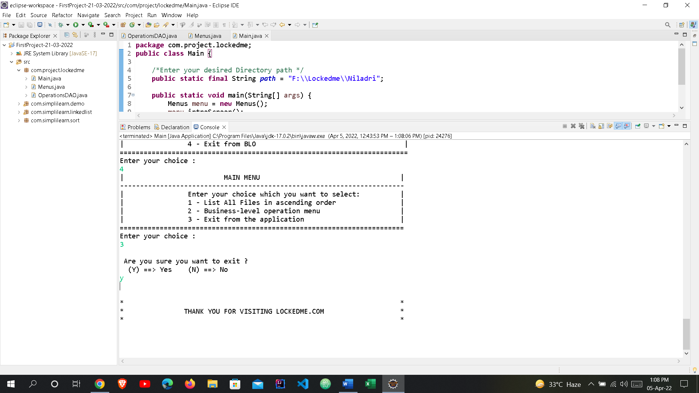

**4. If the user gives any wrong input:**

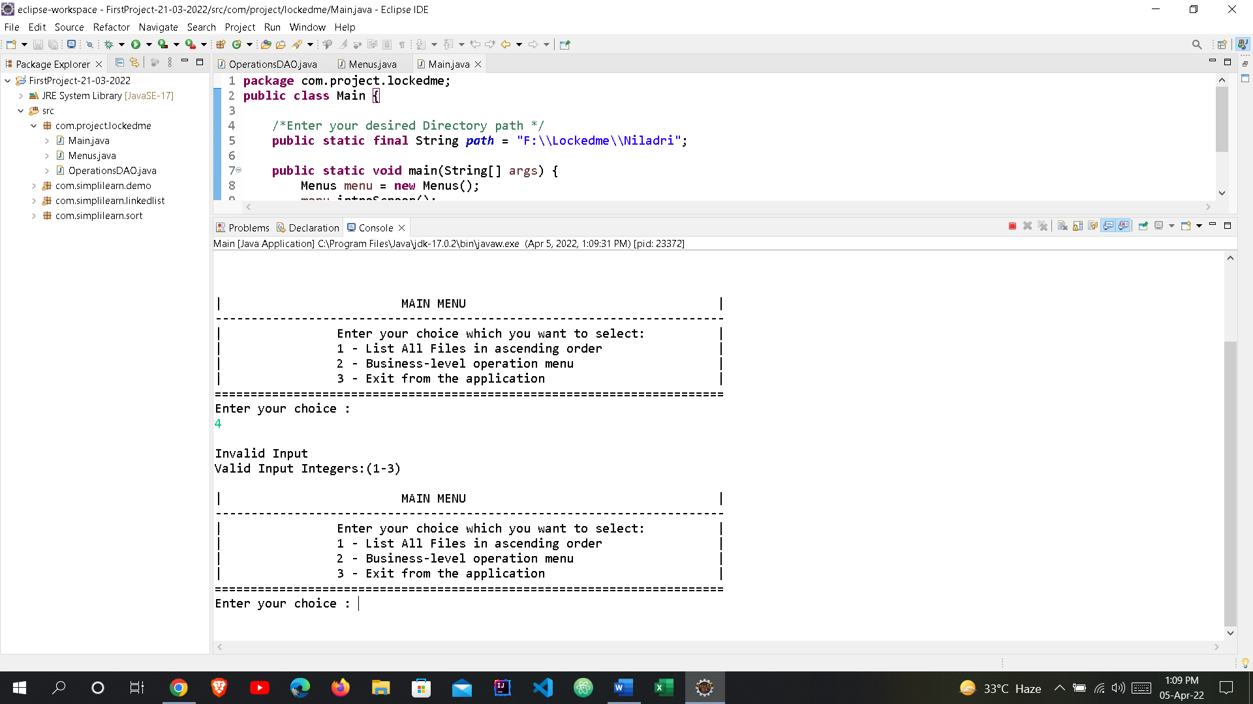

**PROGRAM ENDS**